# University of Science and Technology of Southern Philippines

College of Engineering and Architecture

# Computer Engineering Department

# PROGRESS REPORT

**Proponents: Renzo Miguel Martil** 

**Wilgen Christopher John R. Melendez**

**Kyle Marlowe Moreno**

**Title of Capstone Project:** **Agricultural Tools Identifier Application**

**Week No.: Week 26 Inclusive Dates: Sep. 12-17** 

**Please answer the following:**

1. Describe the current status/stage of the capstone project. Relate with the project's objectives or Gantt chart *(provide pictures or video link if applicable).*

* Collecting Tool Datasets
* Develop Image recognition scanner

Currently, the proponents are focusing on gathering datasets, that would be used in developing the image scanner of the app. Through using these reference images to identify what specific tool is being scanned. Moreover, the proponents are learning and developing the image scanner function of the application using OpenCV, which uses python as its programming language and is equipped with AI and machine learning libraries needed for the development of the application.

<https://www.youtube.com/watch?v=oXlwWbU8l2o&t=832s>

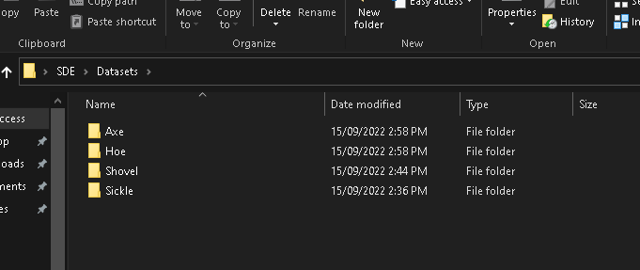

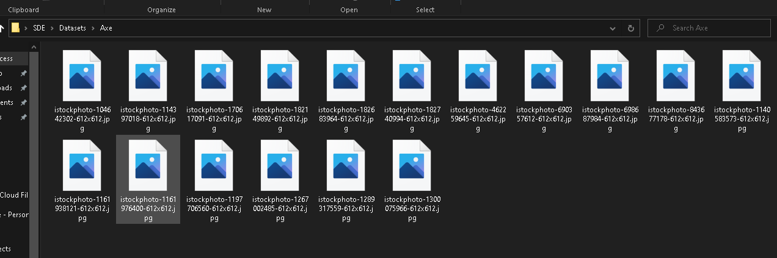

1. Identify problems encountered. Discuss how the problem was resolved *(provide pictures or video links if applicable)*.

* No image datasets that can be downloaded as reference images online, so the proponents must manually download each dataset image in each tool category.

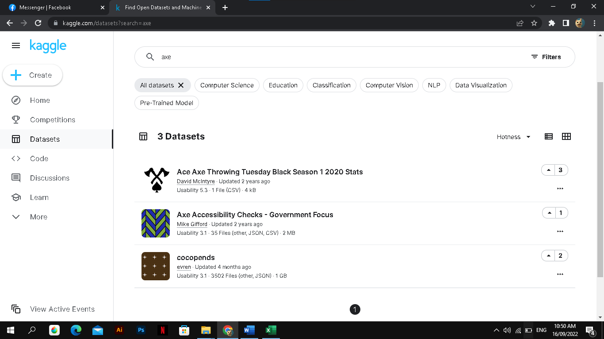

* Currently the proponents are having issues on acquiring a stable internet connection due to having to move in an apartment in CDO for hybrid class. However, will be able to do steady work once internet connection is finally installed.

1. If the problem is unresolved, this is due to (specify reasons):
2. What are your next activities?

* Developing the splash screen
* Developing Camera AI Scanner

**GANTT CHART**